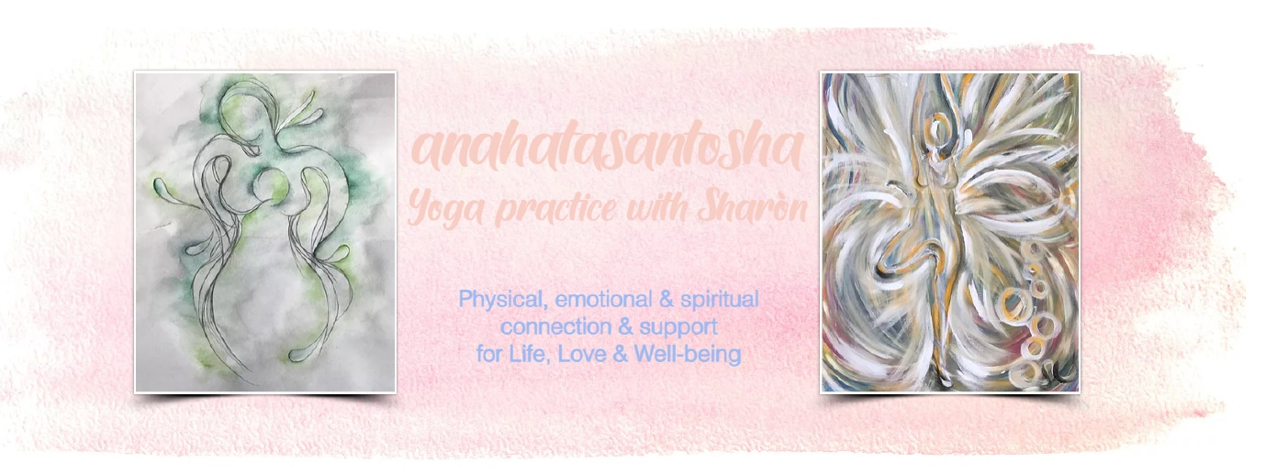
Private Indoor Yoga Practice with Sharòn
Physical, emotional & spiritual connection & support for Life, Love & Well-being

Health Form & Disclaimer
(All information provided is completely confidential & not shared with anyone else)

Name: Date:

Address: Mobile number:

Date of Birth: Email address:

Emergency Contact Name & Mobile Number:

Please circle if you agree to Sharòn holding your personal details, for yoga correspondence purposes only (by call, text, email & WhatsApp) : Yes or No

Please make a note of any physical &/or emotional health-related issues which could be helpful to know about: (Eg. High/Low Blood Pressure, Diabetes, Epilepsy, Neck, Back or Breathing issues, significant surgeries, Pregnancy, Depression, Anxiety, Fatigue, post/Long-COVID related health issues…)

Please be reminded that our yoga practice is done with kindness, compassion & respect. We listen honestly & consciously to our minds & bodies, not forcing or imposing any pain or strain on our precious Selves. Yoga is also potentially an evocative & cleansing practice, so please be aware that you may experience physical & emotional feelings surfacing during or following class. Please also keep me updated of any significant changes in your physical &/or emotional health.

Disclaimer

It is important that you read & understand the following, carefully & sign below & email back or photograph & send on WhatsApp (to bring hard copy to first class)

- I understand that it is my responsibility if necessary, to consult with a Physician/Qualified Medical Practitioner prior to and regarding my participation in this yoga class. I regard myself as physically/emotionally able enough to participate in the class & understand the importance of not imposing any pain upon my body by over-stretching or straining.

- I accept responsibility for informing Sharòn about any medical/emotional conditions, injuries, operations, pregnancy or changes to my health that may affect my practice, prior to a class commencing.

- I recognise that sometimes yoga requires physical exertion, which may potentially be strenuous and if not approached with caution, may cause physical injury. I participate in the practice at my own risk and accept full responsibility for any injury suffered, whether during or outside of class. I will not hold Sharòn responsible for any injury.

- Students will need to confirm that they are healthy & well enough to practice & to inform Sharòn otherwise.

I can confirm that I have read this form carefully & agree to all terms listed:

Signature of participant: Print Name:

Date:

Thank you, Sharòn xx

Mobile 07956671113 Email anahatasantosha@hotmail.com
Website www.anahatasantosha.com

